
Session 4 Supporting Material: Architecture, UML and Workflow Modelling
Reference for Activities 1 to 3: method notes, notation, worked examples on different content, the Case Brief extracts each task needs, and a checklist. It holds no answers to the activities.
Fictional organisation and synthetic data: the organisation, its people and its figures are invented for teaching.

A. Concept list (Activity 1, if you have no concept map or use case)
Twelve concepts from the Kestrel Moor Homes Case Brief, in no particular order. Deciding which become classes, where they sit and how they relate is your work.
Tenant, Household vulnerability, Property, Repair request, Photo, Priority, Job, Appointment, Operative, Contractor, Damp and mould case, Notification.

B. Layers, cohesion, coupling and Kestrel Moor's requirements (Activity 1)
Layer | What goes here | What never goes here
Presentation | Pages, views and API endpoints: show data and collect input | Business rules, SQL, calls to outside systems
Application | Rules, workflows and decisions; services that run a use case; one rules class per policy | Screen layout, SQL, provider-specific code
Data and integration | Entity classes that hold the data; repositories that save and load them; gateways that wrap outside systems | Business rules, screen logic

• Layering rule: calls go down one layer at a time; a page never skips to the data layer.
• Where operations go: on the class whose data they use, except policy rules: rules that change together live in one rules class.
• Tests: describe each class in one sentence without "and" (cohesion); count what else changes if it changes (coupling).
• Maintainability note, rent example: "An arrears policy change touches only ArrearsRules."
Case Brief, Part 5 (the repairs API is slow and cannot be changed):
• MNT-1: Adding a new notification channel (for example WhatsApp or app notifications) must not require changes to the repair request logic.
• MNT-2: Replacing a contractor, or the operative scheduling system, must affect only the part of the system that talks to it.
• MNT-3: Priority rules change when the policy changes; they must be held in one place, not repeated across screens and services.

C. Class diagram notation (Activity 1)
Worked example on different content: a rent account, which is outside the portal's scope.
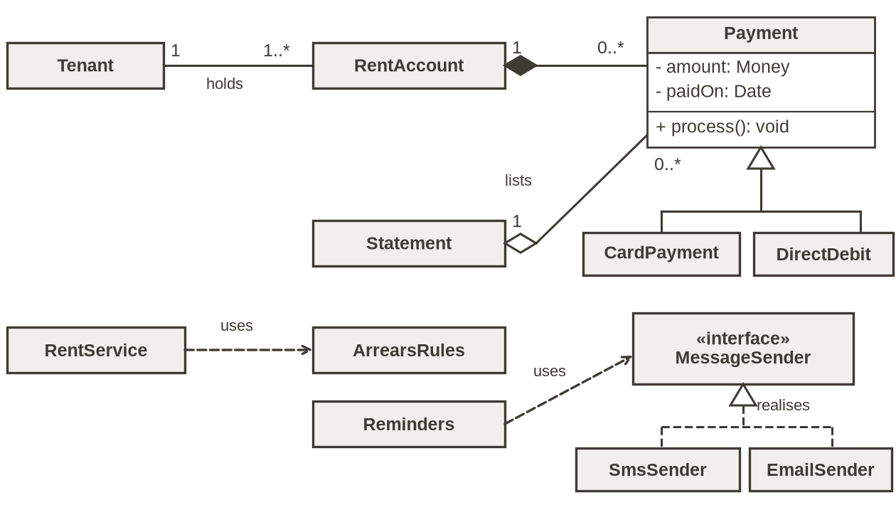
Notation | Meaning | Rent example
Class box: name, attributes, operations | A kind of thing the system holds or does | RentAccount: - balance: Money; + getBalance(): Money
Visibility: - + # | Private, public, protected | - balance is private; + getBalance() is public
Plain line with multiplicities | Association: the two are linked | Tenant 1 to 1..* RentAccount
Filled diamond at the whole | Composition: the part cannot exist without the whole | A RentAccount owns its Payments
Hollow diamond at the whole | Aggregation: the whole groups parts that also exist alone | A Statement lists Payments
Solid line, hollow triangle at the parent | Generalisation: is a kind of | CardPayment is a kind of Payment
Dashed line, hollow triangle at the interface | Realisation: implements an interface | SmsSender implements MessageSender
Dashed line, open arrowhead | Dependency: uses | RentService uses ArrearsRules

Reading multiplicity: start at one class and cross the line; the number at the far end says how many it has. 1 exactly one; 0..1 none or one; 0..* any number; 1..* at least one; 0..3 up to three.
Drawing it in draw.io: search the shape panel for "class" or add More Shapes, UML. Double-click a row to edit it. Draw a connector between two classes and choose its line end and pattern in the Format panel. Paper or PowerPoint shapes work just as well: photograph or screenshot your diagram.

D. Sequence diagram notation (Activity 2)
Worked example on different content: paying rent online, with an alt frame for a declined card.
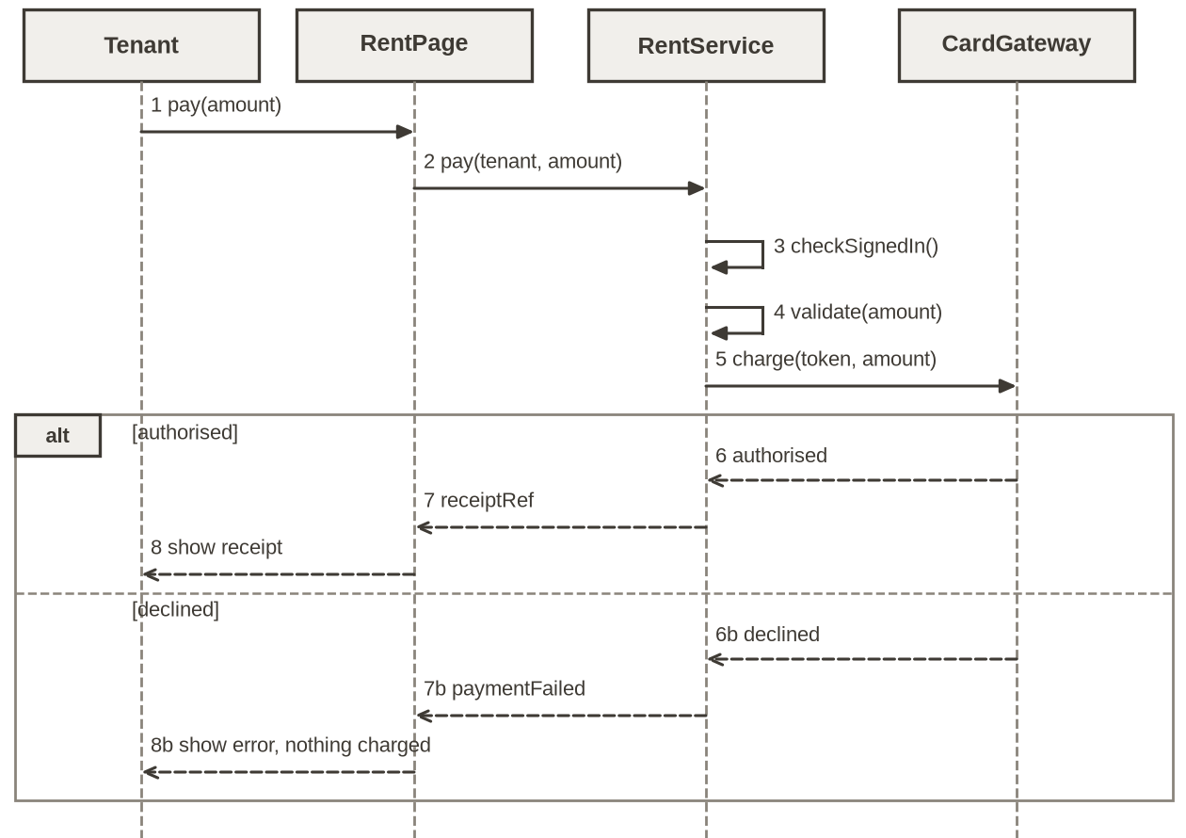
• Lifelines: one per participant, named as in your class diagram. Time runs down the page.
• Calls: solid line, filled arrowhead, named like an operation, for example charge(token, amount). (An open arrowhead on a solid line means an asynchronous message; this module does not use them.)
• Replies: dashed line, open arrowhead, carrying the result back.
• Checks: a self-message on the object that does the check, at the point it happens.
• alt frame: two or more paths, each with its condition in square brackets; each path ends with its own replies.
• Order: a result goes back only after the call that produces it has replied.

E. Worked example: stage times against a target (Activity 3 method)
Made-up library returns, not repair data. The library's target is that every book is checked in within 24 hours of return: a target for each book, not for the average.
Book (A) | Returned (B) | Route (C) | Return to check-in, h (D) | Check-in to shelf, h (E)
LB-201 | Mon 10:15 | Desk | 0.3 | 5.0
LB-202 | Tue 18:30 | Drop box | 14.0 | 4.5
LB-203 | Wed 11:00 | Desk | 0.1 | 6.0
LB-204 | Fri 19:45 | Drop box | 62.0 | 5.5
LB-205 | Thu 20:10 | Drop box | 13.0 | 4.0

1 Split the rows by route, because each route is a different process.
2 Count the books within target for each route: 2 of 3 drop-box books and 2 of 2 desk books were checked in within 24 hours.
3 Give the mean beside the count: check-in takes a mean of 29.7 hours from the drop box and 0.2 at the desk. The drop-box mean is over 24 hours although most drop-box books met the target, and all five books together average 17.9 hours, under 24, although one book in five missed. A mean alone can mislead either way.
4 Read the slowest rows and the median: one Friday-evening return waited 62.0 hours because nobody empties the box at weekends; the drop-box median is 14.0 hours. The slow row is the real problem, not an error.
5 Check the other stage: shelving takes 4.7 and 5.5 hours, well inside any target, so it is not the problem.
6 Draw the path as a swimlane, one lane per person or team, and mark where work waits with its figure.
7 Propose one change and a measure: empty the box on Saturday mornings; track the share of books checked in within 24 hours, by route, for four weeks.
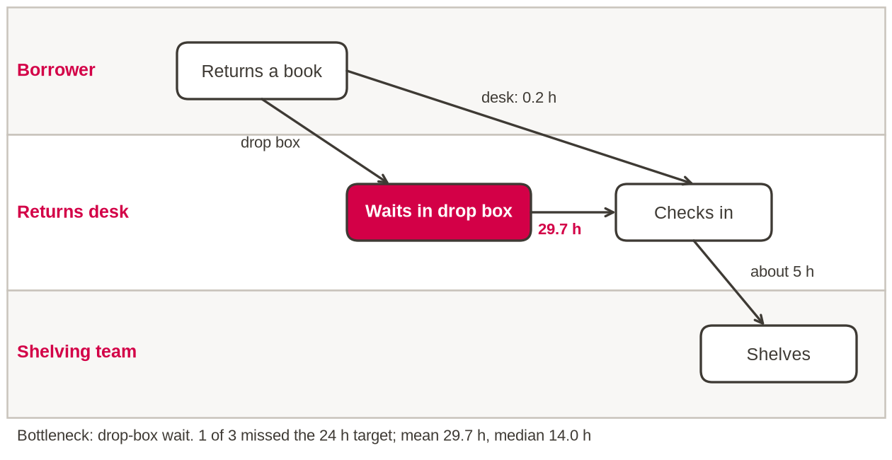

F. Filters, AVERAGEIF and COUNTIFS (Activity 3)
1 Work in your own copy. The filter arrows are already on; find your column letters in the header row.
2 Mean: =AVERAGEIF(range to test, value to match, range to average). Library: =AVERAGEIF(C2:C6,"Drop box",D2:D6) returns 29.7. Format to two decimal places (the status bar shows one).
3 Count within target: =COUNTIFS(range 1, condition 1, range 2, condition 2). Library: =COUNTIFS(C2:C6,"Drop box",D2:D6,"<=24") returns 2. For the share, divide by COUNTIF(range, value).
4 Extension: add a third range and condition, or use AVERAGEIFS, to split by priority.

G. The columns, targets and channels you need (Activity 3)
Columns: channel; hours_report_to_triage, hours_triage_to_booking and hours_booking_to_attend (elapsed calendar hours; the last is blank if not yet attended); priority_assigned. Full definitions: the Data dictionary sheet.
Targets (Case Brief, Part 4, from reported_at): every request is given a priority within 24 hours. Attend Emergency within 24 hours, Urgent 168, damp and mould 336, Routine 672. Triage to booking has no target.
How each channel works today (Case Brief, Part 1):
• Phone: an adviser logs it during the call, 08:00 to 18:00 on weekdays.
• Web form: a queue checked at 09:00 and 14:00 on working days, and by a back-office team in the evenings and at weekends when it has staff free.
• Email: a shared inbox, read "when call volumes allow"; each email is re-typed.
• Housing officer: logged back at a desk, usually the next working day.

H. Checklist: an improvement proposal (Activity 3)
• Evidence: the count within target, with the mean beside it.
• A change to the process or design, with an owner; not "work harder".
• A measure you can compute from the same data, with a target and a date.
• Your own next step, within your remit, and the limits of the evidence (150 requests, six weeks).

